**Functional requirements document**

# General requirements

In the case of no SIM, this APP is able to search for different operators, information of the current cell and the neighbor cell. The operators include Chinese three operators: CMCC,CUCC and CTCC.

Divided into 8 types:

1. In the case of no SIM, search for the current cell and the neighbor cell Info. of CMCC-GSM
2. In the case of no SIM, search for the current cell and the neighbor cell Info. of TD-SCDMA
3. In the case of no SIM, search for the current cell and the neighbor cell Info. of CMCC-LTE
4. In the case of no SIM, search for the current cell and the neighbor cell Info. of CUCC-GSM
5. In the case of no SIM, search for the current cell and the neighbor cell Info. of WCDMA
6. In the case of no SIM, search for the current cell and the neighbor cell Info. of CUCC-LTE
7. In the case of no SIM, search for the current cell and the neighbor cell Info. of CTCC-CDMA
8. In the case of no SIM, search for the current cell and the neighbor cell Info. of CTCC-LTE

# Detailed description

After searching for the current and neighbor cell of corresponding operator, the information we need as follows:

1. In view of the CDMA network, we need to achieve all the call info. through the AT+ECEL instruction. Specific pattern as follows:

+ECELL:<num_of_cell>[,<Act>,<cid>,<lac_or_tac>,<mcc>,<mnc>,<psc_or_pci>,<sig1>,<sig2>,<sig1_in_dbm>,<sig2_in_dbm>,<ta>,<ext1>,<ext2>][,…].

1. In view of the CDMA network, we need to achieve all the call info. through these two instructions.

1）**AT+ ECENGINFO =1,19** Specific pattern as follows:

+ECENGINFO:“1xRTT_Radio_Info”,<channel>,<band_class>,<pilot_pn_offset>,<rx_power1>,<rx_power2>,<tx_power>,<tx_ant_id>,<FER>

+ECENGINFO:”1xRTT_Info”,<cp_state>,<Calibration>,<RfFileMajorVersion>,<RfFileMinorVersion>,<RfFileValueVersion>,<RfFileCustVersion>,<sid>,<nid>,<sys_det_ind>,<reg_zone>,<base_lat>,<base_long>,<network_pref_sci>,<qpch_mode>,<mcc>,<imsi_11_12>,<pkt_zone_id>,<so>,<t_add>,<t_drop>,<t_comp>,<t_tdrop>

+ECENGINFO:”1xRTT_Serving_Neighbr_Set_Info”,<num_in_active_set>,<pilot_pn_1>,<pilot_ecio_1>,<pilot_phase_1>,…,<pilot_pn_n>,<pilot_ecio_n>,<pilot_phase_n>,<num_in_cand_set>,<pilot_pn_1>,<pilot_ecio_1>,<pilot_phase_1>,…,<pilot_pn_n>,<pilot_ecio_n>,<pilot_phase_n>,<num_in_nghbr_set>,<pilot_pn_1>,<pilot_ecio_1>,<pilot_phase_1>,…,<pilot_pn_n>,<pilot_ecio_n>,<pilot_phase_n>

2）**AT+VLOCINFO?**,Specific pattern as follows:

AT < +VLOCINFO:6,460,3,13840,18,12724,448260,1751492

1. These following cell information from every operators need to be showed in the APP, the red fields can’t be achieved through AT order and need to be solved.

|  |  |
| --- | --- |
| Operator | Filed info. |
| Search for CMCC-GSM with no SIM | LAC,CID,**CH,BSI**C,RX |
| Search for CUCC-GSM with no SIM |
| Search for TD-SCDMA with no SIM | LAC,CID,**CH,CPI**,RX |
| Search for WCDMA with no SIM | LAC,CID**,CH**,PSC,RX |
| Search for CDMA with no SIM | SID,NID,BID,PN,RX |
| Search for CMCC-LTE with no SIM | TAC,**ECI,CH**,PCI,RX |
| Search for CUCC-LTE with no SIM |
| Search for CTCC-LTE with no SIM |

The following screenshots of every operators, FYI

1. CMCC -GSM

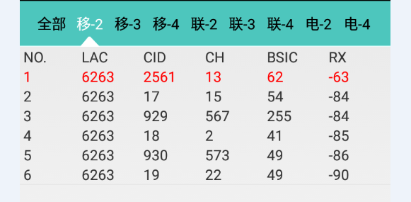

1. TDSCDMA

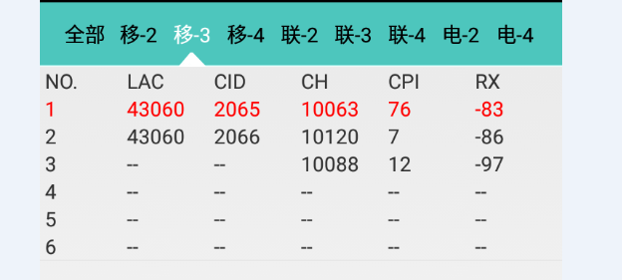

1. CMCC-LTE

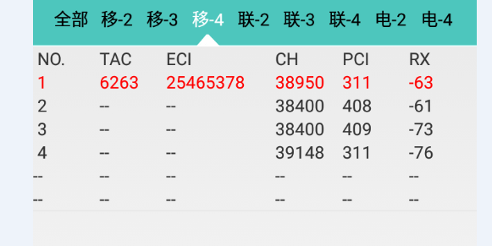

1. CUCC -GSM

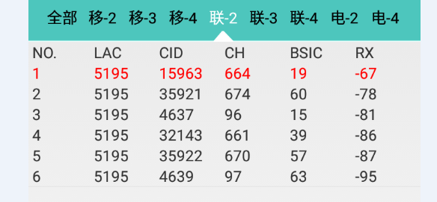

1. WCDMA

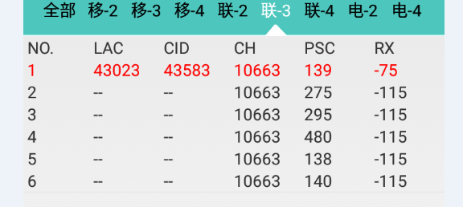

1. CUCC -LTE

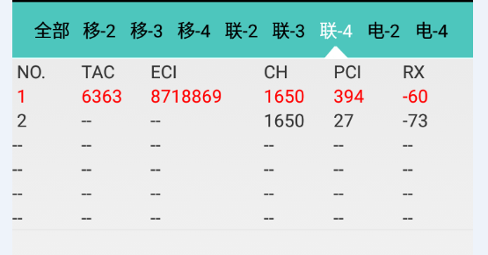

1. CTCC -CDMA

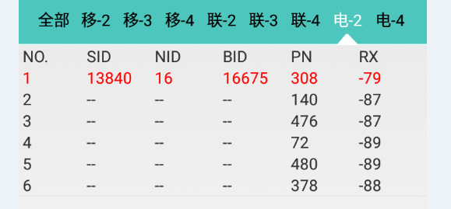

1. CTCC -LTE

